PABNA UNIVERSITY OF SCIENCE AND TECHNOLOGY



Faculty of Engineering & Technology
Department of Information and Communication Engineering
LAB REPORT
Course name: Signals & Systems Sessional
Course Code: ICE-2204

Submitted By: Submitted To:
Name: Sohel Ahamed Dr. Md. Imran Hossain
Roll: 220634 Associate Professor
Session: 2021-22 Department of ICE, PUST
2nd Year 2st Semester
Department of ICE, PUST

Date of Submission:03.03.2023

SL | Problem Statement
01 | Signal Operations (Addition, Shifting, Folding)
02 | Implementation of Convolution
03 | Implementation of Correlation
04 | Signal Sequence (Unit step, unit ramp, unit sample)
05 | PPG Signal Processing (Filtering, Feature Extraction, Peak Detection, Heart Rate (HR), Systolic & Diastolic Peaks, Pulse Transit Time (PTT))
06 | Fourier Transform
07 | Discrete Fourier Transform (DFT)
INDEX

Signal & System Lab Report
Experiment No-1. Signal Operations (Addition, Shifting, Folding)

Theory
Signal operations include basic transformations such as addition, shifting (time delay or advance), and folding (time reversal). These operations are fundamental in signal processing.

1. Signal Addition
Signal addition is a basic arithmetic operation where two signals are added point-by-point. Mathematically, if we have two discrete-time signals x1(n) and x2(n) their sum is given by:
y(n)=x1(n)+x2(n)

2. Shifting (Time Shifting)
Time shifting modifies a signal by shifting it forward (delay) or backward (advance) along the time axis.
- Right Shift (Delay): y(n)=x(n−k), where k>0
- Left Shift (Advance): y(n) = x(n+k), where k>0

3. Folding (Time Reversal)
Folding, also known as time reversal, reflects a signal about n=0 Mathematically:
y(n)=x(−n)

Objective
To perform addition, shifting, and folding of discrete-time signals in Python.

Code
import numpy as np
import matplotlib.pyplot as plt
def signal_operations():
n = np.arange(-10, 11) # Create time index from -10 to 10
x = np.sin(0.2 * np.pi * n) # Example signal (sine wave)
y=np.sin(0.5*np.pi*n)
signal_ad=x+y
# Shift right by 3 positions, and handle the boundary values
x_shifted = np.roll(x, 3) # Initialize with zeros
x_shifted[:3] = 0 # Set the first 3 elements to zero # Shift the signal right by 3, leave zeros at the start
# Time reversal (folding the signal)
x_folded = np.flip(x) # Reverse the signal
# Plotting the results
plt.figure(figsize=(10, 8))
# Original signal plot
plt.subplot(4, 1, 1)
plt.stem(n, x)
plt.title("Original Signal")
plt.xlabel("n")
plt.ylabel("x[n]")
plt.subplot(4, 1, 2)
plt.plot(signal_ad)
plt.title("Signal Add")
plt.xlabel("n")
plt.ylabel("x[n] and Y[n]")
# Shifted signal plot
plt.subplot(4, 1, 3)
plt.stem(n, x_shifted)
plt.title("Shifted Signal (Right by 3)")
plt.xlabel("n")
plt.ylabel("x[n]")
# Folded signal plot
plt.subplot(4, 1, 4)
plt.stem(n, x_folded)
plt.title("Folded Signal")
plt.xlabel("n")
plt.ylabel("x[n]")
# Adjust layout to avoid overlap
plt.tight_layout()
plt.show()
# Run the function to see the result
signal_operations()
Output
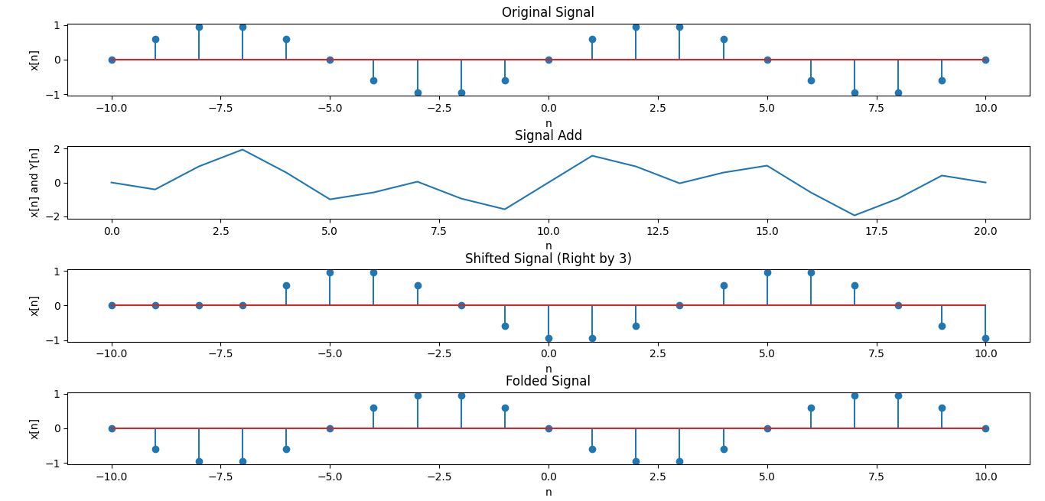
Experiment No-2. Convolution

Theory
Convolution is a fundamental mathematical operation in signal processing and system analysis. It describes how an input signal interacts with a system's impulse response to produce an output signal. In simple terms, convolution helps determine the response of a system when an input is applied.

Mathematical Definition of Convolution
For continuous-time signals, convolution is defined as:
y(t)= (x∗ h) (t)= $\int_{-∞}^{∞}{x\left(τ\right)h\left(t-τ\right)dτ}$
where:
- x(t)is the input signal,
- h(t) is the impulse response of the system,
- y(t) is the output signal,
- τ is a dummy variable for integration,
- (x ∗ h) (t)denotes the convolution operation.
For discrete-time signals (used in digital signal processing), convolution is represented as:
y[n] = (x ∗h) [n]=$\sum_{-∞}^{∞}{x\left[k\right]h\left[n-k\right]}$
where:
- x[n] is the discrete input signal,
- h[n] is the discrete impulse response,
- y[n] is the discrete output signal,
- The summation runs over all integer values of k.

Objective
To perform discrete-time convolution using Python.

Code
import numpy as np
import matplotlib.pyplot as plt
# Define the input signal x[n] and impulse response h[n]
x = np.array([1, 2, 3, 4, 5]) # Example input signal
h = np.array([1, -1, 2]) # Example impulse response
# Perform the convolution using numpy's convolve function
y = np.convolve(x, h, mode='full')
# Create time indices for the signals
n_x = np.arange(len(x))
n_h = np.arange(len(h))
n_y = np.arange(len(y))
# Plot the input, impulse response, and output
plt.figure(figsize=(10, 6))
plt.subplot(3, 1, 1)
plt.stem(n_x, x)
plt.title('Input Signal x[n]')
plt.xlabel('n')
plt.ylabel('x[n]')
plt.subplot(3, 1, 2)
plt.stem(n_h, h)
plt.title('Impulse Response h[n]')
plt.xlabel('n')
plt.ylabel('h[n]')
plt.subplot(3, 1, 3)
plt.stem(n_y, y)
plt.title('Output Signal y[n] (Convolution of x[n] and h[n])')
plt.xlabel('n')
plt.ylabel('y[n]')
plt.tight_layout()
plt.show()

Output
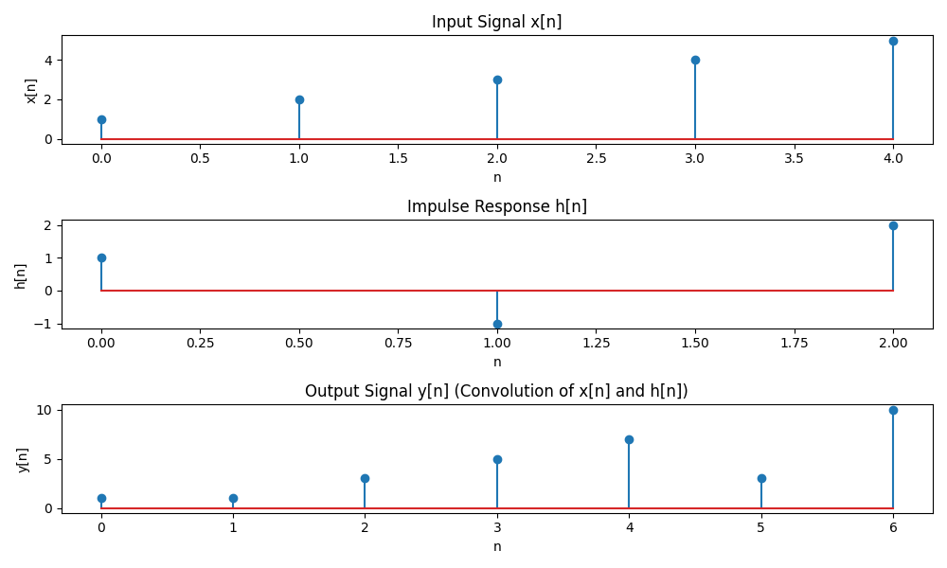

Experiment No-3. Correlation
Theory
Correlation measures the similarity between two signals over time. Correlation is a mathematical operation used to measure the similarity between two signals as a function of time or displacement. It determines how much one signal resembles another when shifted by a certain amount. Correlation is widely used in signal processing, pattern recognition, and communications.

Mathematical Definition of Correlation

Continuous-Time Cross-Correlation
The cross-correlation of two continuous signals x(t) and y(t) is defined as:
$R_{xy}\left(τ\right)$= $\int_{-∞}^{∞}{x\left(t\right)y\left(t+τ\right)dt}$
where:
- x(t)and y(t) are the two signals,
- $R_{xy}\left(τ\right)$is the correlation function,
- τ represents the shift (or lag),
- The integral sums the product of x(t) and a shifted version of y(t)

Discrete-Time Cross-Correlation
For discrete signals x[n] and y[n], the correlation is given by:
$R_{xy}\left(m\right)$= $\sum_{n=-∞}^{∞}{x\left[n\right]y\left[n+m\right]}$
where:
- $R_{xy}\left(m\right)$is the cross-correlation function at shift mmm,
- The summation accumulates the product of x[n] and the shifted y[n].
.

Objective
To compute cross-correlation between two signals in Python.
Code
import numpy as np
import matplotlib.pyplot as plt
# Auto-Correlation Function
def auto_correlation(signal):
correlation = np.correlate(signal, signal, mode='full')
return correlation[correlation.size // 2:] # Only non-negative lags
# Cross-Correlation Function
def cross_correlation(signal1, signal2):
correlation = np.correlate(signal1, signal2, mode='full')
return correlation[correlation.size // 2:] # Only non-negative lags
# Example signals
t = np.linspace(0, 1, 500, endpoint=False)
signal1 = np.sin(2 * np.pi * 5 * t) # A sine wave with 5 Hz frequency
signal2 = np.sin(2 * np.pi * 5 * t + np.pi / 4) # A sine wave with a phase shift
# Compute auto-correlation and cross-correlation
auto_corr_signal1 = auto_correlation(signal1)
cross_corr = cross_correlation(signal1, signal2)
# Plotting the results
plt.figure(figsize=(12, 6))
# Auto-correlation plot
plt.subplot(1, 2, 1)
plt.plot(auto_corr_signal1)
plt.title('Auto-Correlation of Signal 1')
plt.xlabel('Lag')
plt.ylabel('Correlation')
# Cross-correlation plot
plt.subplot(1, 2, 2)
plt.plot(cross_corr)
plt.title('Cross-Correlation between Signal 1 and Signal 2')
plt.xlabel('Lag')
plt.ylabel('Correlation')
plt.tight_layout()
plt.show()

Output
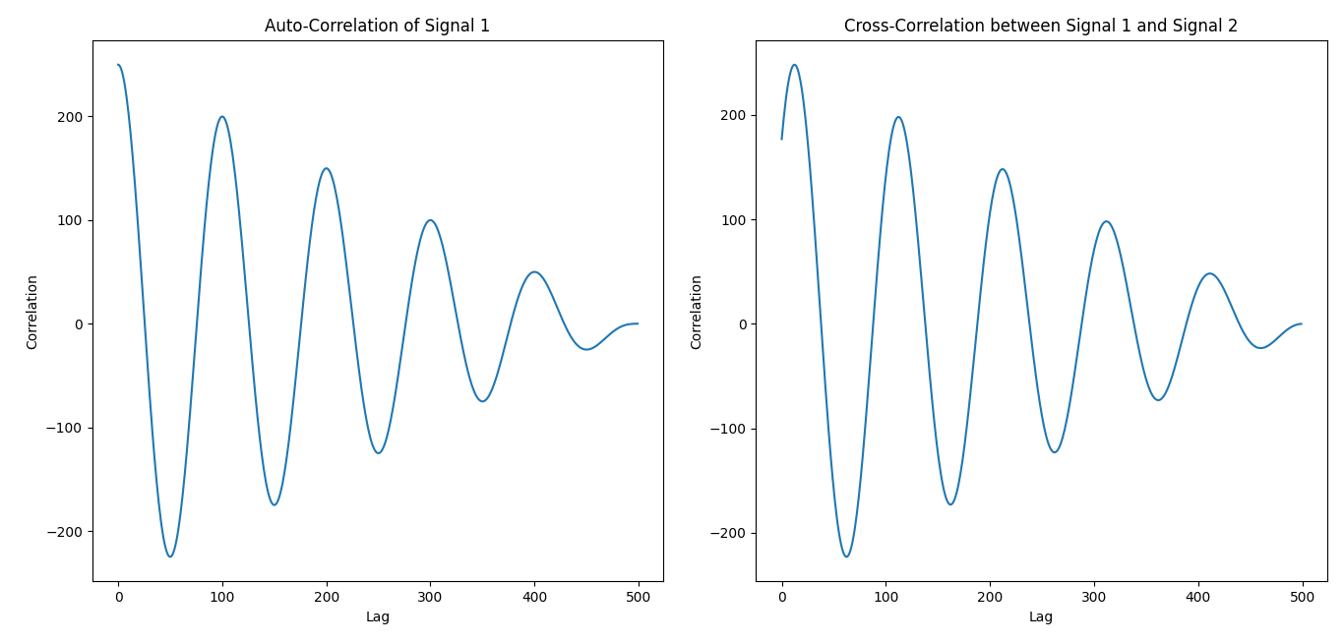
Experiment No-4. Signal Sequence

Theory
A signal sequence represents a series of values over discrete time. In the study of Signals & Systems, some basic signals form the foundation for understanding more complex signals. Three such fundamental signals are:
- Unit Step Signal u[n]
- Unit Sample (Impulse) Signal δ[n]
- Unit Ramp Signal r[n]

1.Unit Step Signal u[n]

Definition:

The unit step signal, also called the Heaviside function, is defined as:
u[n]= {(1, ​n≥0)(0, n<0)}​

2. Unit Sample (Impulse) Signal δ[n]

Definition:
The unit impulse function, also called the Kronecker delta function, is defined as:
δ[n]={(1,n=0)(0,n≠0)}

3. Unit Ramp Signal r[n]

Definition:
The unit ramp signal is a sequence that increases linearly with n:
r[n]={(n,n≥0)(0,n<0)
Objective
To generate a discrete-time signal sequence and visualize it.
Code
import numpy as np
import matplotlib.pyplot as plt
# Unit sample sequence
unit_sample = np.zeros(10)
unit_sample[5] = 1
# Unit step signal
unit_step = np.heaviside(np.arange(-5, 5), 1)
# Unit ramp signal
unit_ramp = np.arange(10)
plt.figure(figsize=(12, 6))
plt.subplot(3, 1, 1)
plt.stem(unit_sample)
plt.title("Unit Sample Sequence")
plt.subplot(3, 1, 2)
plt.stem(unit_step)
plt.title("Unit Step Signal")
plt.subplot(3, 1, 3)
plt.stem(unit_ramp)
plt.title("Unit Ramp Signal")
plt.tight_layout()
plt.show()
OUTPUT
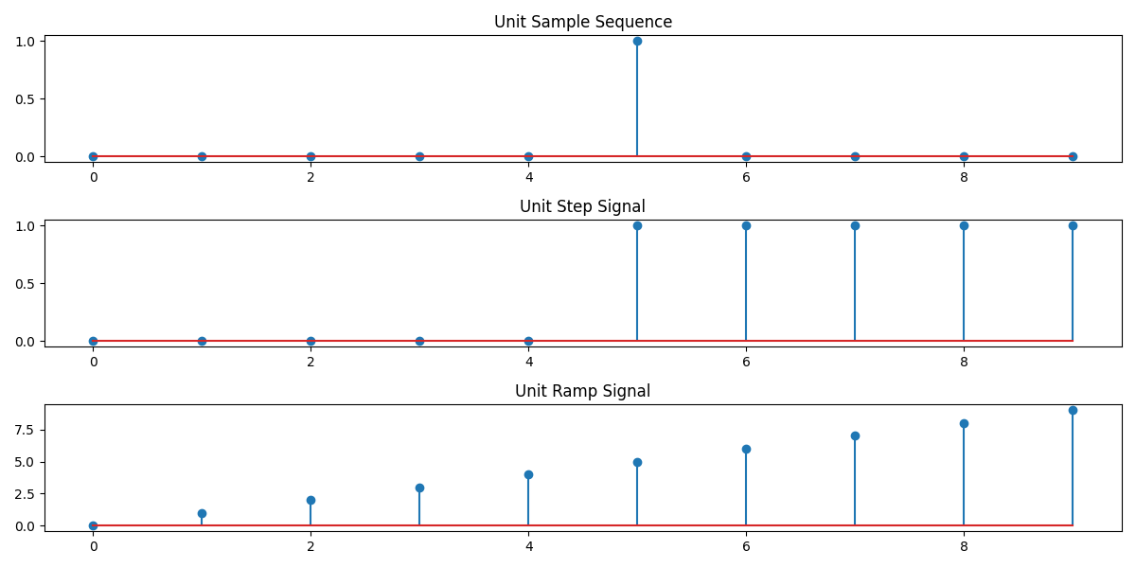

Experiment No-5. PPG Signal Processing (Filtering, Feature Extraction, Peak Detection, Heart Rate (HR), Systolic & Diastolic Peaks, Pulse Transit Time (PTT))

Theory
A PPG (Photoplethysmography) signal is an optical technique used to measure blood volume changes in the microvascular tissue. It is commonly used for heart rate monitoring and oxygen saturation (SpO₂) measurement.

Working Principle of PPG Signal:
- Light Emission & Absorption: An LED emits light onto the skin, which is either absorbed or reflected by the blood vessels.
- Detection: A photodetector measures the amount of reflected or transmitted light, which varies with blood flow.
- Signal Processing: The detected variations are converted into a PPG waveform, which represents the pulsatile changes in blood volume with each heartbeat.
Good ppg signal:
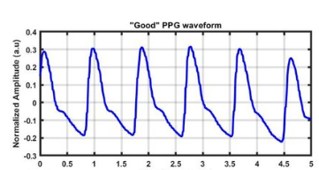
Fig-01:Good Ppg signal
Features of PPG (Photoplethysmography) Signal
1.Raw ppg signal: A raw PPG (Photoplethysmogram) signal represents the variation in light absorption due to changes in blood volume in the microvascular bed of tissue. It’s typically measured using a photodetector, like in smartwatches or pulse oximeters, and provides information about heart rate, blood oxygen levels, and other cardiovascular parameters.The raw PPG signal consists of AC Component and DC Component.
Raw ppg signal CODE
import numpy as np
import pandas as pd
import matplotlib.pyplot as plt
from scipy.signal import find_peaks, butter, filtfilt
# Generate sample PPG signal
np.random.seed(0)
time = np.linspace(0, 10, 1000)
ppg_signal = np.sin(2 * np.pi * 1.2 * time) + 0.5 * np.random.normal(size=len(time))
# Define the lowpass filter function
def butter_lowpass_filter(data, cutoff, fs, order=5):
nyquist = 0.5 * fs
normal_cutoff = cutoff / nyquist
b, a = butter(order, normal_cutoff, btype='low', analog=False)
y = filtfilt(b, a, data)
return y
# Plot 1: Raw PPG Signal
plt.figure(figsize=(12, 6))
plt.plot(time, ppg_signal, label="Raw PPG Signal", alpha=0.5)
plt.title("Raw PPG Signal")
plt.xlabel("Time (s)")
plt.ylabel("Amplitude")
plt.grid()
plt.legend() plt.show()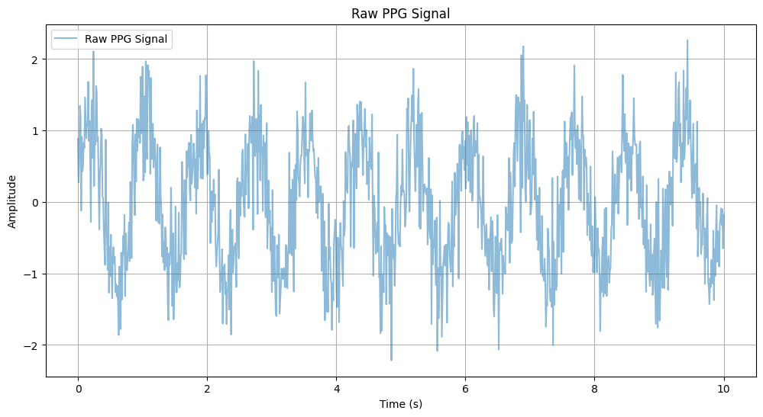
2.Filtered PPG signal:
# Filter settings
fs = 100 # Sampling frequency in Hz
cutoff = 3 # Cutoff frequency in Hz
filtered_ppg = butter_lowpass_filter(ppg_signal, cutoff, fs)
# Plot 2: Filtered PPG Signal
plt.figure(figsize=(12, 6))
plt.plot(time, filtered_ppg, label="Filtered PPG Signal", linewidth=2)
plt.title("Filtered PPG Signal")
plt.xlabel("Time (s)")
plt.ylabel("Amplitude")
plt.grid()
plt.legend()
plt.show()
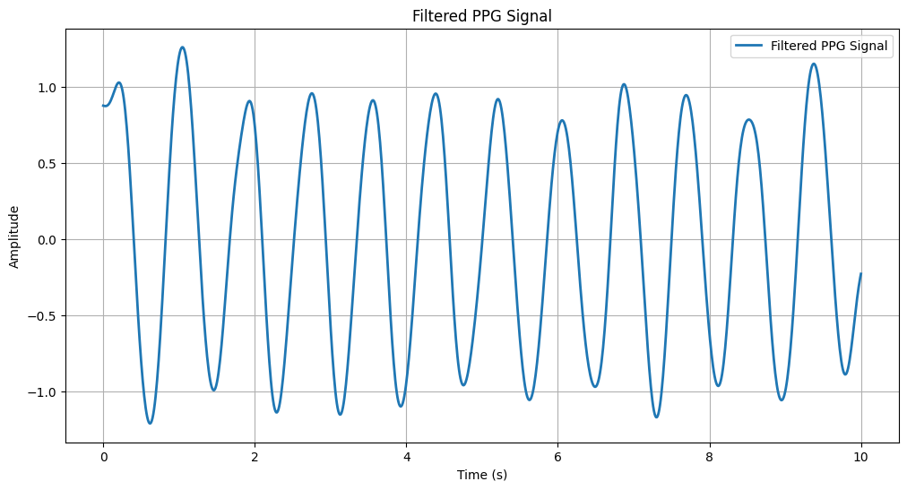
3.Peaks And Value:
# Peak and valley detection
peaks, _ = find_peaks(filtered_ppg, height=0.5, distance=fs//2)
valleys, _ = find_peaks(-filtered_ppg, height=0.5, distance=fs//2)
# Plot 3: Peaks and Valleys
plt.figure(figsize=(12, 6))
plt.plot(time, filtered_ppg, label="Filtered PPG Signal", linewidth=2)
plt.plot(time[peaks], filtered_ppg[peaks], "go", label="Detected Peaks")
plt.plot(time[valleys], filtered_ppg[valleys], "ro", label="Detected Valleys")
plt.title("Detected Peaks and Valleys")
plt.xlabel("Time (s)")
plt.ylabel("Amplitude")
plt.grid()
plt.legend()
plt.show()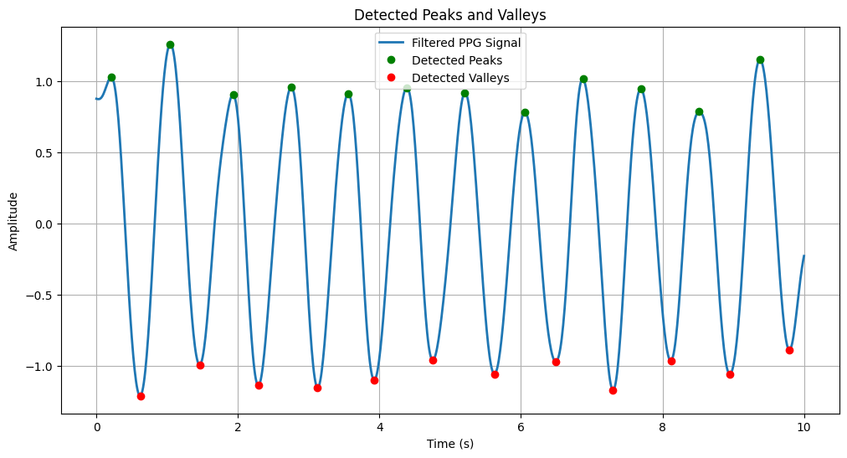

4. Abnormal Peaks:
# Abnormal peaks detection
peak_heights = filtered_ppg[peaks]
abnormal_peaks = peaks[peak_heights > 1] # Threshold for high spikes
# Plot 4: Abnormal Peaks
plt.figure(figsize=(12, 6))
plt.plot(time, filtered_ppg, label="Filtered PPG Signal", linewidth=2)
plt.plot(time[abnormal_peaks], filtered_ppg[abnormal_peaks], "kx", label="Abnormal Peaks", markersize=10)
plt.title("Abnormal Peaks Detection")
plt.xlabel("Time (s)")
plt.ylabel("Amplitude")
plt.grid()
plt.legend()
plt.show()
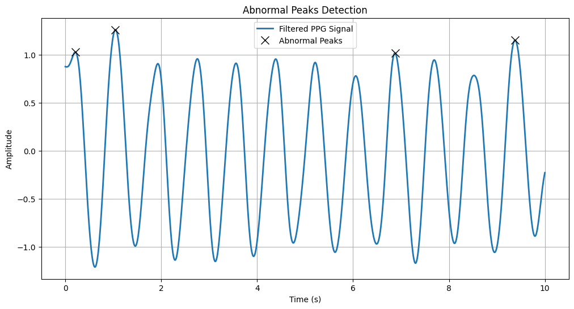
5. Heart Rate (HR)
# Heart Rate (HR) calculation
peak_times = time[peaks]
hr = 60 / np.diff(peak_times) # Beats per minute
# Plot 5: Heart Rate (HR)
plt.figure(figsize=(12, 6))
plt.plot(peak_times[1:], hr, label="Heart Rate (HR)", marker='o')
plt.title("Heart Rate (HR)")
plt.xlabel("Time (s)")
plt.ylabel("Beats per Minute (BPM)")
plt.grid()
plt.legend()
plot.show()
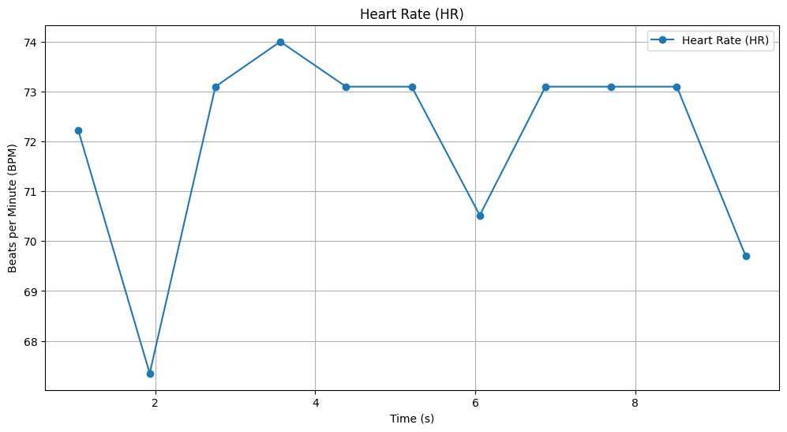
6. Systolic & Diastolic Peaks
# Systolic & Diastolic Peaks
systolic_peaks = peaks
diastolic_peaks = valleys
# Plot 6: Systolic & Diastolic Peaks
plt.figure(figsize=(12, 6))
plt.plot(time, filtered_ppg, label="Filtered PPG Signal", linewidth=2)
plt.plot(time[systolic_peaks], filtered_ppg[systolic_peaks], "go", label="Systolic Peaks", markersize=8)
plt.plot(time[diastolic_peaks], filtered_ppg[diastolic_peaks], "ro", label="Diastolic Peaks", markersize=8)
plt.title("Systolic and Diastolic Peaks")
plt.xlabel("Time (s)")
plt.ylabel("Amplitude")
plt.grid()
plt.legend()
plt.show()
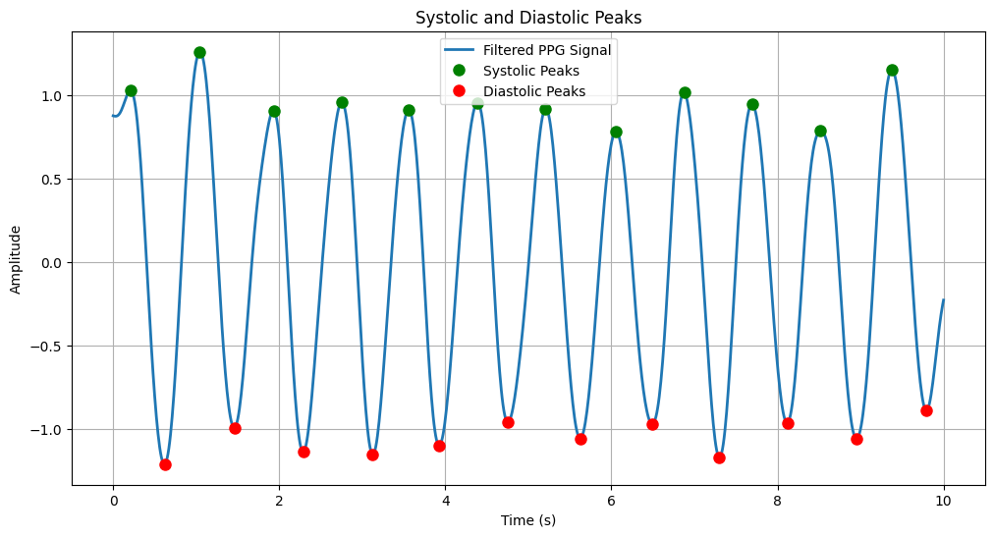
7 Blood Oxygen Saturation (SpO₂).
# Blood Oxygen Saturation (SpO₂) simulation
# Assuming SpO₂ is inversely proportional to the amplitude of the PPG signal
spo2 = 100 - (filtered_ppg * 10) # Simulated SpO₂ values
# Plot 7: Blood Oxygen Saturation (SpO₂)
plt.figure(figsize=(12, 6))
plt.plot(time, spo2, label="Blood Oxygen Saturation (SpO₂)", linewidth=2)
plt.title("Blood Oxygen Saturation (SpO₂)")
plt.xlabel("Time (s)")
plt.ylabel("SpO₂ (%)")
plt.grid()
plt.legend()
plt.show()
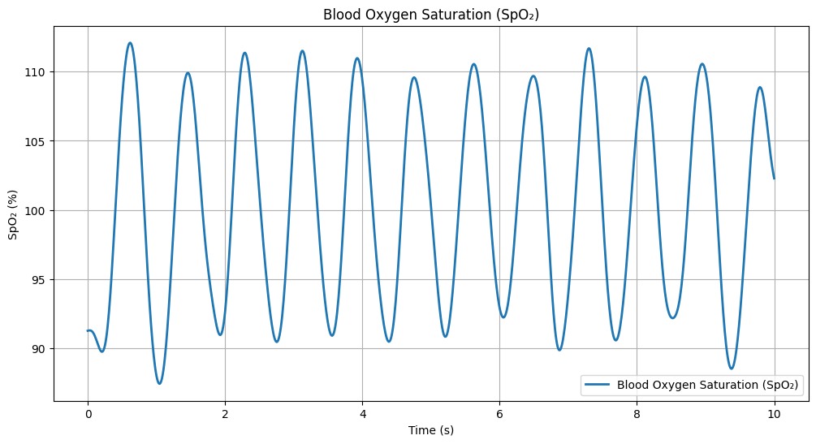
8. Pulse Transit Time (PTT)
# Pulse Transit Time (PTT) simulation
# Assuming PTT is the time difference between systolic and diastolic peaks
ptt = np.zeros(len(systolic_peaks))
for i in range(len(systolic_peaks)):
if i < len(diastolic_peaks):
ptt[i] = time[diastolic_peaks[i]] - time[systolic_peaks[i]]
# Plot 8: Pulse Transit Time (PTT)
plt.figure(figsize=(12, 6))
plt.plot(time[systolic_peaks[:len(ptt)]], ptt, label="Pulse Transit Time (PTT)", marker='o')
plt.title("Pulse Transit Time (PTT)")
plt.xlabel("Time (s)")
plt.ylabel("PTT (s)")
plt.grid()
plt.legend()
plt.show()
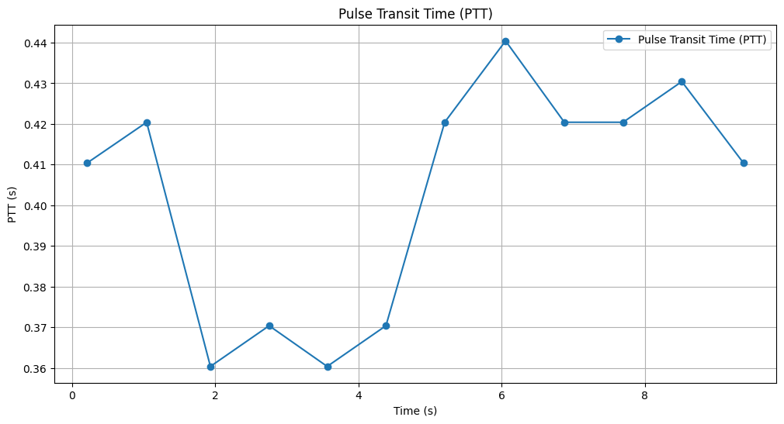

---
Experiment No- 6. Fourier Transform

Theory
Fourier Transform converts a time-domain signal into its frequency components. The Fourier Transform (FT) is a mathematical operation that converts a time-domain signal into its frequency-domain representation. It allows us to analyze how different frequency components contribute to the original signal.

Mathematical Definition of Fourier Transform

Continuous-Time Fourier Transform (CTFT)
For a continuous-time signal x(t)), the Fourier Transform is given by:
X (f$)=\int_{-∞}^{∞}{x\left(t\right)}e^{-j2πft}dt$
where:
- X(f) is the Fourier Transform (frequency-domain representation).
- x(t) is the original signal in the time domain.
- $e^{-j2πft}$represents complex sinusoids (Euler’s formula).
- f is the frequency in Hertz (Hz).

Discrete-Time Fourier Transform (DTFT)
For discrete-time signals (used in digital signal processing), the Fourier Transform is:
X($e^{jω})\sum_{n=-∞}^{∞}{x\left[n\right]e^{-jωn}}$
where:
- X ($e^{jω})$is the DTFT,
- x[n] is the discrete-time signal,
- ω is the angular frequency in radians per sample.

Objective
To compute the Fourier Transform of a signal.

Code
import numpy as np
import matplotlib.pyplot as plt
from scipy.fft import fft, ifft, fftfreq
# Generate a sample audio signal
Fs = 1000 # Sampling rate (1000 Hz)
T = 1 / Fs # Sampling interval
t = np.linspace(0, 1, Fs, endpoint=False) # 1 second time vector
# Generate a pure sine wave (440 Hz, like an "A4" musical note)
freq_signal = 440
pure_signal = np.sin(2 * np.pi * freq_signal * t)
# Add random noise
noise = np.random.normal(0, 0.5, pure_signal.shape)
noisy_signal = pure_signal + noise
# Apply FFT
fft_signal = fft(noisy_signal)
freqs = fftfreq(len(fft_signal), T) # Frequency bins
# Filter: Remove frequencies higher than 500 Hz
fft_filtered = fft_signal.copy()
fft_filtered[np.abs(freqs) > 500] = 0 # Zero out high frequencies (noise)
# Apply Inverse FFT to get the cleaned signal
cleaned_signal = ifft(fft_filtered).real
# Plot the results
plt.figure(figsize=(12, 6))
plt.subplot(3, 1, 1)
plt.plot(t, pure_signal, label="Original Signal (440 Hz)")
plt.legend()
plt.title("Original Pure Signal")
plt.subplot(3, 1, 2)
plt.plot(t, noisy_signal, label="Noisy Signal", color="red")
plt.legend()
plt.title("Noisy Signal")
plt.subplot(3, 1, 3)
plt.plot(t, cleaned_signal, label="Cleaned Signal (After FFT Filtering)", color="green")
plt.legend()
plt.title("Filtered Signal (Noise Removed)")
plt.tight_layout()
plt.show()

Output
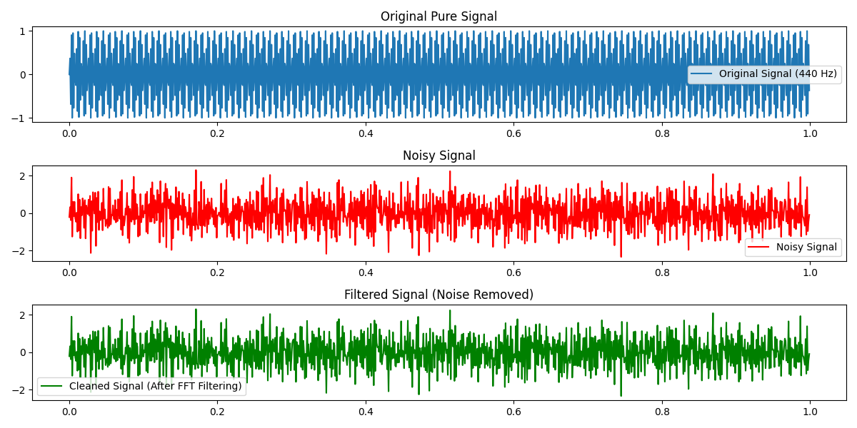
Experiment No- 7. Discrete Fourier Transform (DFT)

Theory
The Discrete Fourier Transform (DFT) is a mathematical tool used to analyze the frequency components of a finite-length discrete-time signal. It transforms a sequence of time-domain samples into a frequency-domain representation, allowing us to understand how different frequencies contribute to the signal.
For a discrete-time signal x[n] of length N, the DFT is defined as
X($K)=\sum_{n=0}^{n-1}{x\left[n\right]e^{-j2pikn/N}}$,k=0,1……N-1

where:
- X (K$)$ represents the DFT output at frequency index k
- x[n] is the discrete-time signal,
- ω is the angular frequency in radians per sample.
- k represents discrete frequency bins.
Objective
To compute the DFT of a signal using Python.
Code
import numpy as np
import matplotlib.pyplot as plt
def DFT(x):
"""
Compute the Discrete Fourier Transform (DFT) of a 1D signal.
"""
N = len(x)
X = np.zeros(N, dtype=complex) # Output array (complex numbers)
for k in range(N): # Loop over frequency bins
for n in range(N): # Loop over time samples
X[k] += x[n] * np.exp(-2j * np.pi * k * n / N)
return X
# Create a sample signal (two sine waves)
Fs = 1000 # Sampling rate
T = 1 / Fs # Sampling interval
t = np.linspace(0, 1, Fs, endpoint=False) # 1 second duration
# Signal: Combination of 50 Hz and 120 Hz sine waves
f1, f2 = 50, 120
signal = np.sin(2 * np.pi * f1 * t) + 0.5 * np.sin(2 * np.pi * f2 * t)
# Compute DFT
dft_output = DFT(signal)
# Compute frequency bins
freqs = np.fft.fftfreq(len(dft_output), T)
# Plot magnitude spectrum (single-sided)
plt.figure(figsize=(10, 5))
plt.plot(freqs[:Fs//2], np.abs(dft_output[:Fs//2])) # Single-sided spectrum
plt.title("DFT Frequency Spectrum")
plt.xlabel("Frequency (Hz)")
plt.ylabel("Magnitude")
plt.grid()
plt.show()
Output
